ATIC Accessibility

To support the accessible community in making informed travel decisions for their individual needs

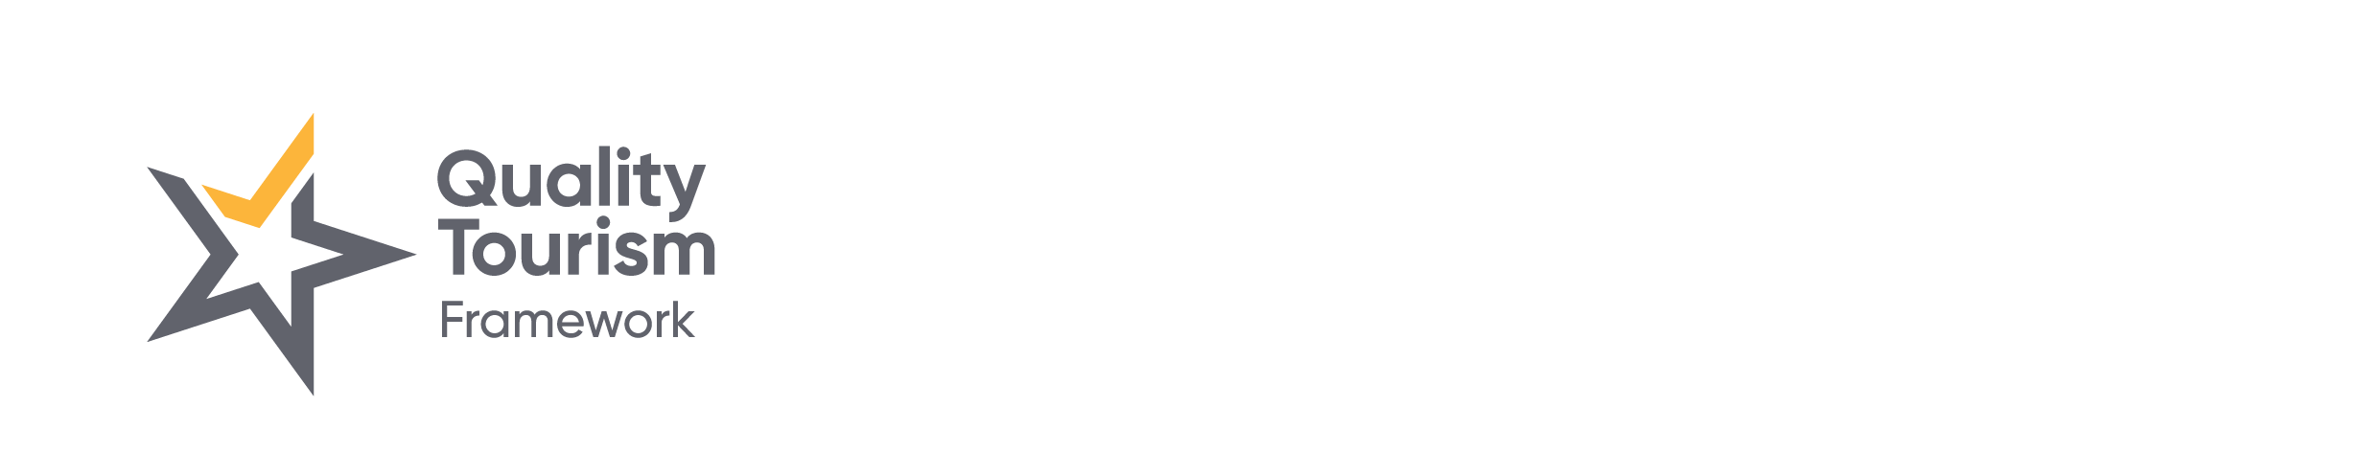

This report prepared for:

|  |  |
| --- | --- |
| Business name: | Eco Abrolhos Cruises |
| Address: | 6 Baker Street |
| Town: | Geraldton |
| Date: | 2023-06-30 14:47 |

ATIC Accessibility

The following pages provides travellers with information on the businesses facilities and amenities which aims to support the traveller to make an informed decision on whether the business is suitable for their individual needs.

OVERVIEW 4

Business Overview 4

Bookings 4

Emergency Management 4

Communications 5

GENERAL 7

Pre-arrival, arrival and reception 7

Entry 7

Internal Spaces 7

Public areas 8

Displays, exhibits, commentary and live performances 8

External Paths 8

Steps 8

TOUR OPERATORS 9

Tour/Transport Services 9

Route Planning 9

Guides 9

ACCOMMODATION 10

Room Amenities 10

Bathrooms 10

ATTRACTIONS 11

COMMON AREAS 12

Parks and gardens 12

FOOD AND DRINK 13

Dining Spaces 13

ADVENTURE ACTIVITIES 14

Report Disclaimer 15

# OVERVIEW

## Business Overview

The business has the following products/services available

* Tour/Transport
* Accommodation
* Attraction
* Food and Drink
* Adventure

Our business caters for the following disability types:

* Food allergies or intolerances

## Bookings

The business offers the following methods for bookings and enquiries:

* Phone
* Email
* Webportal
* Our website supports Screen Readers
* Our forms have high contract boxes and submit boxes

## Emergency Management

* Emergency and evacuation procedures are explained on arrival
* There are Audible device/s to alert occupants to evacuate with instructions on how to evacuate.
* There are visual device/s to alert occupants to evacuate.
* Exit signs are clear and easy to see
* Exit access is free and clear at all times

We ensure exit access is free and clear at all times by:

Crew are diligent to ensure access on boats is not blocked

* Exits and access to exists are greater than 900mm
* Exit doors are able to be opened by all occupants
* Exits including stairwells, have bright edges used on the steps.
* The evacuation point is clearly marked by a sign

The business identifies guests who need additional assistance should an emergency occur by:

Mobility needs are assessed on arrival at a private induction interview

The procedure for assisting guests who need assisted rescue is:

Crew are made aware on each cruise of any Guests who have limited mobility at a toolbox meeting

## Communications

The business provides the following services for services animals:

Nil

# GENERAL

## Pre-arrival, arrival and reception

The business has the following in place to support guests during pre-arrival, arrival and reception

* There is a reception/public entryway.
* Seating available at reception
* A lower counter at reception/ticket office
* A clipboard to allow check-in/ticket purchase whilst seated

NA

* Information and maps are available in written form

No locks to accessible facilities

* Luggage assistance

The following steps are in place to ensure that people with fatigue related to their disability are not disadvantaged by long wait times:

N/A

* In addition, the following further information can assist guests:

N/A

* In addition, the following further information can assist guests:

N/A

## Entry

The business has the following amenities/systems in place for entry

* A drop off point close to the entrance

## Internal Spaces

* Clear and unobstructed routes through and between buildings
* Interior walls are matte or low sheen
* Floor surfaces are hard or short pile carpet
* Seating is available for guests unable to stand for long periods
* All corridors greater than 900mm

## Public areas

The public areas have the following amenities in place

* Even lighting
* Seating

## Displays, exhibits, commentary and live performances

For displays, exhibits, commentary and live performances the following amenities are in place

* Seating
* Wheelchair accessible spaces/seating

## External Paths

External paths of travel have the following amenities are in place

* Pathways are wider than 900mm
* There 3 successive steps or less on any path or at any doorway

## Steps

Steps have the following amenities are in place

* There are steps.
* Handrails fitted to all open sets of steps

# TOUR OPERATORS

## Tour/Transport Services

The tour/transport services have the following facilities/amenities in place

* Busses/Coaches
* 0 vehicles have wheelchair lifts or ramps
* 0 vehicles have low floors with ramped entry

The maximum wheelchair capacity available in the fleet is:

0

## Route Planning

* Overnight Stops
* A total of 0 wheelchair passengers can be catered for overnight stops
* Walking Tours
* Multi-paced to account for slower walkers

## Guides

Guides have been trained in the following

* Use of clear/simple English
* Marine
* Accessibility is tide dependent

Image(s)

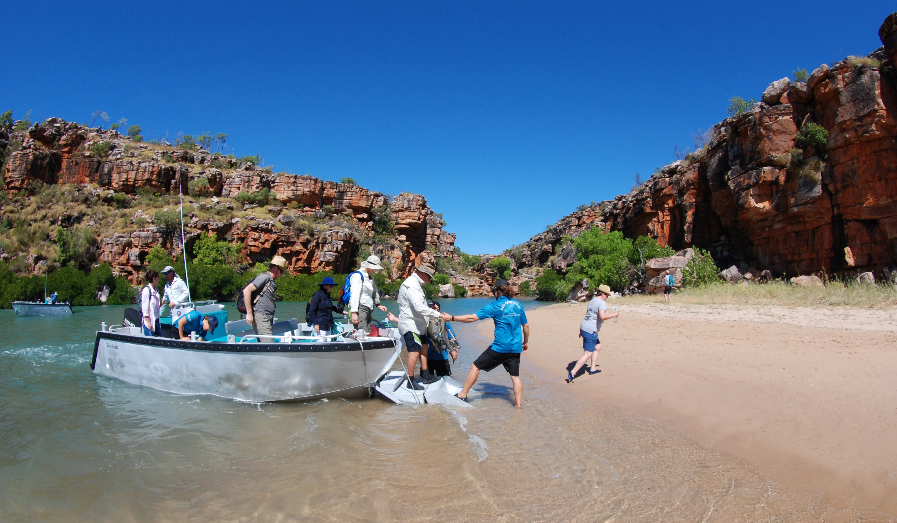

DSC_3500 (2)

# ACCOMMODATION

## Room Amenities

For guests with a hearing impairment, the following emergency evacuation procedures apply to ensure safe evacuation:

This would be advised to crew at Tool Box Meeting and recorded in Guest details

* Openings are a minimum of ? wide
* There at least one chair with rigid arms
* The bed height is no higher than 680mm from the floor

## Bathrooms

The bathrooms have the following facilities/amenities in place

* All heating appliances and hot water pipes are protected or insulated
* All shower, bath and basin taps are clearly differentiated between hot and cold
* The width of the door is ?.
* The width beside the toilet is ?.
* There is Marine bathrooms are tight mm of clear space in front of the toilet
* The actual height of the toilet seat is ?.
* There is a portable shower head on flexible hose
* A door is fitted to the shower

Bathroom Image(s)

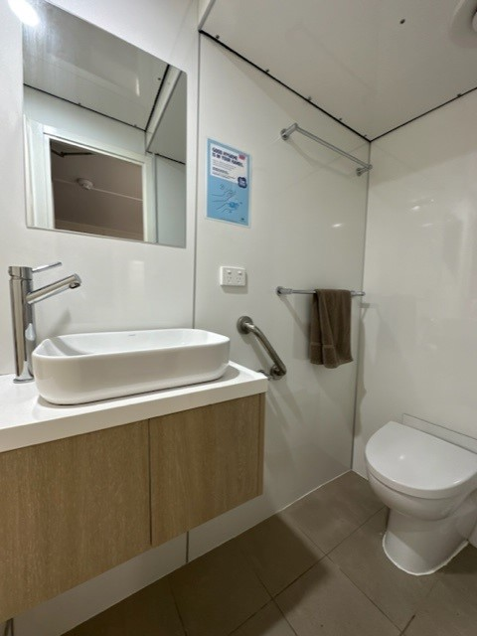

Cabin 16 bathroom photo

# ATTRACTIONS

# COMMON AREAS

## Parks and gardens

* Handrails and stairs are built as per state/territory building code.
* Slip resistance surfaces are used.
* A handrail is available and at 865-965mm in height.

# FOOD AND DRINK

## Dining Spaces

The dining spaces have the following facilities/amenities in place

* The doorway is at least 850mm wide
* There is level access through the dining area
* Chairs are moveable to allow for wheelchairs to be seated at the tables
* All glass doors and full height windows have contrast markings
* There are areas of full lighting
* There is an accessible toilet

Our business caters for the following dietary requirements

* Sugar free (diabetic)
* Gluten free (celiac)
* Lactose free (dairy free)
* Low fat and fibre with no gastric content
* Low potassium
* Low sodium
* Nut free
* Vegetarian
* Vegan
* There are procedures in place to avoid cross-contamination of food products

# ADVENTURE ACTIVITIES

Adventure Activity Image(s)



DSC_3500 (2)

## Report Disclaimer

Please note that this business report, provided as a result of the use of the diagnostic assessment, is for information purposes only.

Australian Tourism Industry Council (ATIC) cannot guarantee the accuracy of respondent’s answers, or that they are fully representative of your business. Therefore, ATIC does not warrant or guarantee any particular outcome in respect of your businesses self-assessment.

This report is intended as guidance only for your business and should not be relied on for future marketing considerations. ATIC recommends that you seek your own independent advice as well as the results from the diagnostic.

Links to external web sites are inserted for convenience and do not constitute endorsement of material at those sites, or any associated organisation, product or service.

ATIC does not:

1. Assume any legal liability for the accuracy, completeness, or usefulness of any information from this report or any links provided; or
2. Accept responsibility for any loss associated directly or indirectly from the use of this report